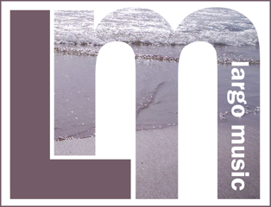
Booking
Form
Book here for the 2022 Gartmore House Saxophone Weekend (15-17 April 2022).

Full residential fee, shared or single room: £433 pp
Non-residential fees (includes all meals): £243 pp
Non-residential fees (without dinner): £203 pp

Name:

Address:

Contact Telephone Nos:

Email Address:

Instrument(s):

Playing standard:

Fees are payable, by 6th February 2022, in two ways:

1. By direct Bank Transfer, Largo Music: Acct 10945072;
Sort 83-26-28 (Please include your name in the reference to the payment.)

2. By cheque to Largo Music, 19 The Temple, Lower Largo, Leven, Fife KY8 6JH

Please send this booking form to: Courses@largo-music.co.uk
We will confirm your booking in due course. Participants must be over 18.

Booking conditions

Full fees
If you cancel, for whatever reason, we will try to find a paying replacement and if successful will refund your payment. However, we cannot guarantee to find a replacement and if we are unsuccessful will then retain the total fee in order to cover the costs we will incur. We strongly advise you to insure yourself against this eventuality. It is not unknown for someone to have to cancel at the last minute for very good reasons but we cannot afford to make any other refunds, even if you have to cancel for covid-related reasons. We apologise if these conditions seem a little harsh but remind you that the event runs without any outside support.

